2020-2021

Playschoolers Supply List

3-year old’s

* 8ct. (Large) Crayola Crayons
* 8ct. Crayola Fine Line Markers
* 2 or 3 ct. Glue Sticks
* 4ct. Play-Doh
* (1) 2-Pocket Folder
* 1 Box Gallon Size Bags
* 1 Hand Sanitizer
* 1 Clorox Wipes
* 1 Box Tissues

4 & 5-year old’s

* 8ct. (regular size) Crayola Crayons
* 1ct. Blunt Tip Scissors
* 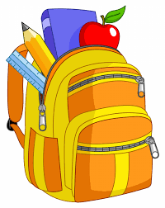8ct. Crayola Fine Line Markers
* 2 or 3ct. Glue Sticks
* 4ct. Play-Doh
* (1) 2-Pocket Folder
* 1 Box Quart Size Storage Bags
* 1 Hand Sanitizer
* 1 Clorox Wipes
* 1 Box Tissues

\*\*Optional\*\*

Coloring Books and Trinkets for our Treasure Box

Supplies due by August 3, 2020 (First Day of School)